EXPT NO:2 | Implementation of data visualization techniques
ROLL NO:23BAD078 | Implementation of data visualization techniques
DATE: 06.01.2026 | Implementation of data visualization techniques

PRE-LAB QUESTIONS (PROVIDE BRIEF ANSWERS TO THE FOLLOWING QUESTIONS)
- Why is exploratory data analysis critical before model building?
- How do distributions influence algorithm selection in ML?
- What insights can outliers provide in business data?
- Why are visual summaries preferred over raw tables?
- How does visualization improve business intelligence?
Answers:
- EDA helps in understanding the structure, patterns, and quality of data before applying any machine learning model. It helps identify missing values, outliers, trends, and relationships, ensuring the data is suitable and reliable for model building.
- The distribution of data affects which algorithm performs best. Some algorithms assume normal distribution (e.g., linear regression), while others are robust to skewed or non-linear data (e.g., decision trees). Understanding distributions helps in choosing the right algorithm and preprocessing techniques.

- Outliers can indicate:
- Fraudulent activities
- Operational issues
- High-value customers
- Market anomalies
- Visual summaries make data easy to understand and interpret quickly. They help users identify trends, comparisons, and anomalies at a glance, whereas raw tables are time-consuming and harder to analyze.
- Visualization improves business intelligence by:
- Converting complex data into actionable insights
- Supporting data-driven decision making
- Helping stakeholders monitor performance and trends
- Enabling faster and clearer communication of results
IN-LAB EXERCISE:
OBJECTIVE:

To explore data distribution and variability using advanced visualization techniques.
SCENARIO:
A startup analyzes e-commerce transaction data to understand customer spending behavior and detect abnormal purchase patterns.

IN-LAB TASKS (Using R Language)
- Plot histogram of transaction amounts
- Use boxplot to detect outliers
- Create heatmap of monthly sales intensity

Code:

library(readr)
library(ggplot2)
library(dplyr)

X2_ecommerce_transactions <- read_csv("2.ecommerce_transactions.csv")

# Assign to a simple variable name
data <- X2_ecommerce_transactions

head(data)

ggplot(data, aes(x = Transaction_Amount)) +
geom_histogram(bins = 15, fill = "steelblue", color = "black") +
labs(title = "Distribution of Transaction Amounts",
x = "Transaction Amount",
y = "Frequency") +
theme_minimal()

ggplot(data, aes(y = Transaction_Amount)) +
geom_boxplot(fill = "orange") +
labs(title = "Boxplot of Transaction Amounts",
y = "Transaction Amount") +
theme_minimal()

data <- data %>%
mutate(Month = format(Transaction_Date, "%b"))

monthly_sales <- data %>%
group_by(Month, Region) %>%
summarise(Sales_Count = n(), .groups = "drop")

ggplot(monthly_sales, aes(x = Month, y = Region, fill = Sales_Count)) +
geom_tile() +
labs(title = "Monthly Sales Intensity Heatmap",
x = "Month",
y = "Region") +
theme_minimal()

OUTPUT:

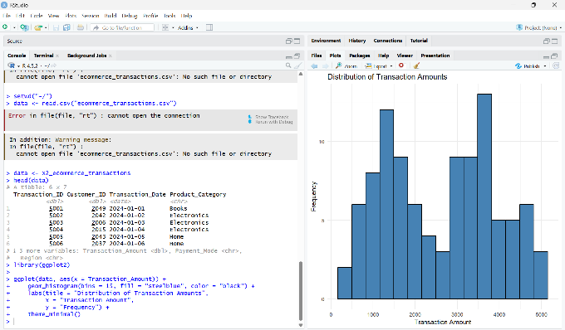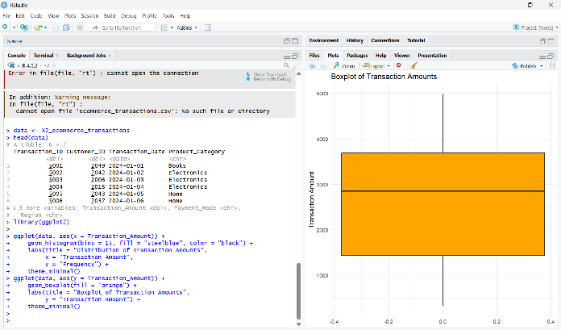

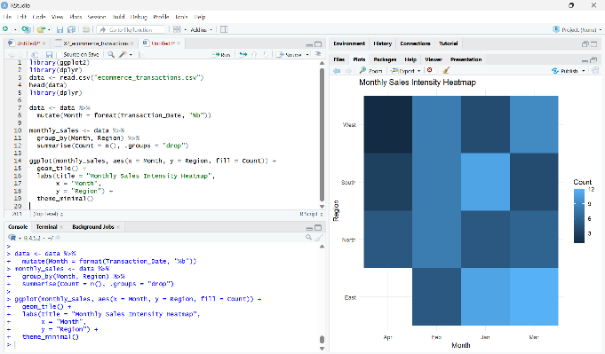

(CODE: CONATAINS STUDENT ROLL NOS
SCREENSHOT OF CODE
SCREENSHOT OF OUTPUT)

POST-LAB QUESTIONS (PROVIDE BRIEF ANSWERS TO THE FOLLOWING QUESTIONS)
- What does right-skewed distribution indicate about customer behavior?
- How can detected outliers impact business decisions?
- Which visualization best supports anomaly detection?
- How does EDA improve AI model accuracy?
- How can visualization guide feature engineering?

ANSWERS:

- A right-skewed distribution indicates that most customers make low-value purchases, while a few customers make very high-value transactions. This suggests the presence of premium or bulk buyers alongside regular customers.

- Outliers can:
- Indicate high-value customers
- Reveal fraudulent or abnormal transactions
- Help design targeted marketing or loyalty programs

- A boxplot best supports anomaly detection because it clearly highlights outliers as points outside the whiskers, making abnormal values easy to identify.

- EDA improves AI model accuracy by:
- Identifying noise, outliers, and missing values
- Revealing data patterns and distributions
- Enabling proper data preprocessing and feature selection
- Visualization helps by:
- Identifying important variables
- Suggesting transformations (e.g., log scale for skewed data)
- Highlighting relationships between features

ASSESSMENT
Description | Max Marks | Marks Awarded
Pre Lab Exercise | 5
In Lab Exercise | 10
Post Lab Exercise | 5
Viva | 10
Total | 30
Faculty Signature

